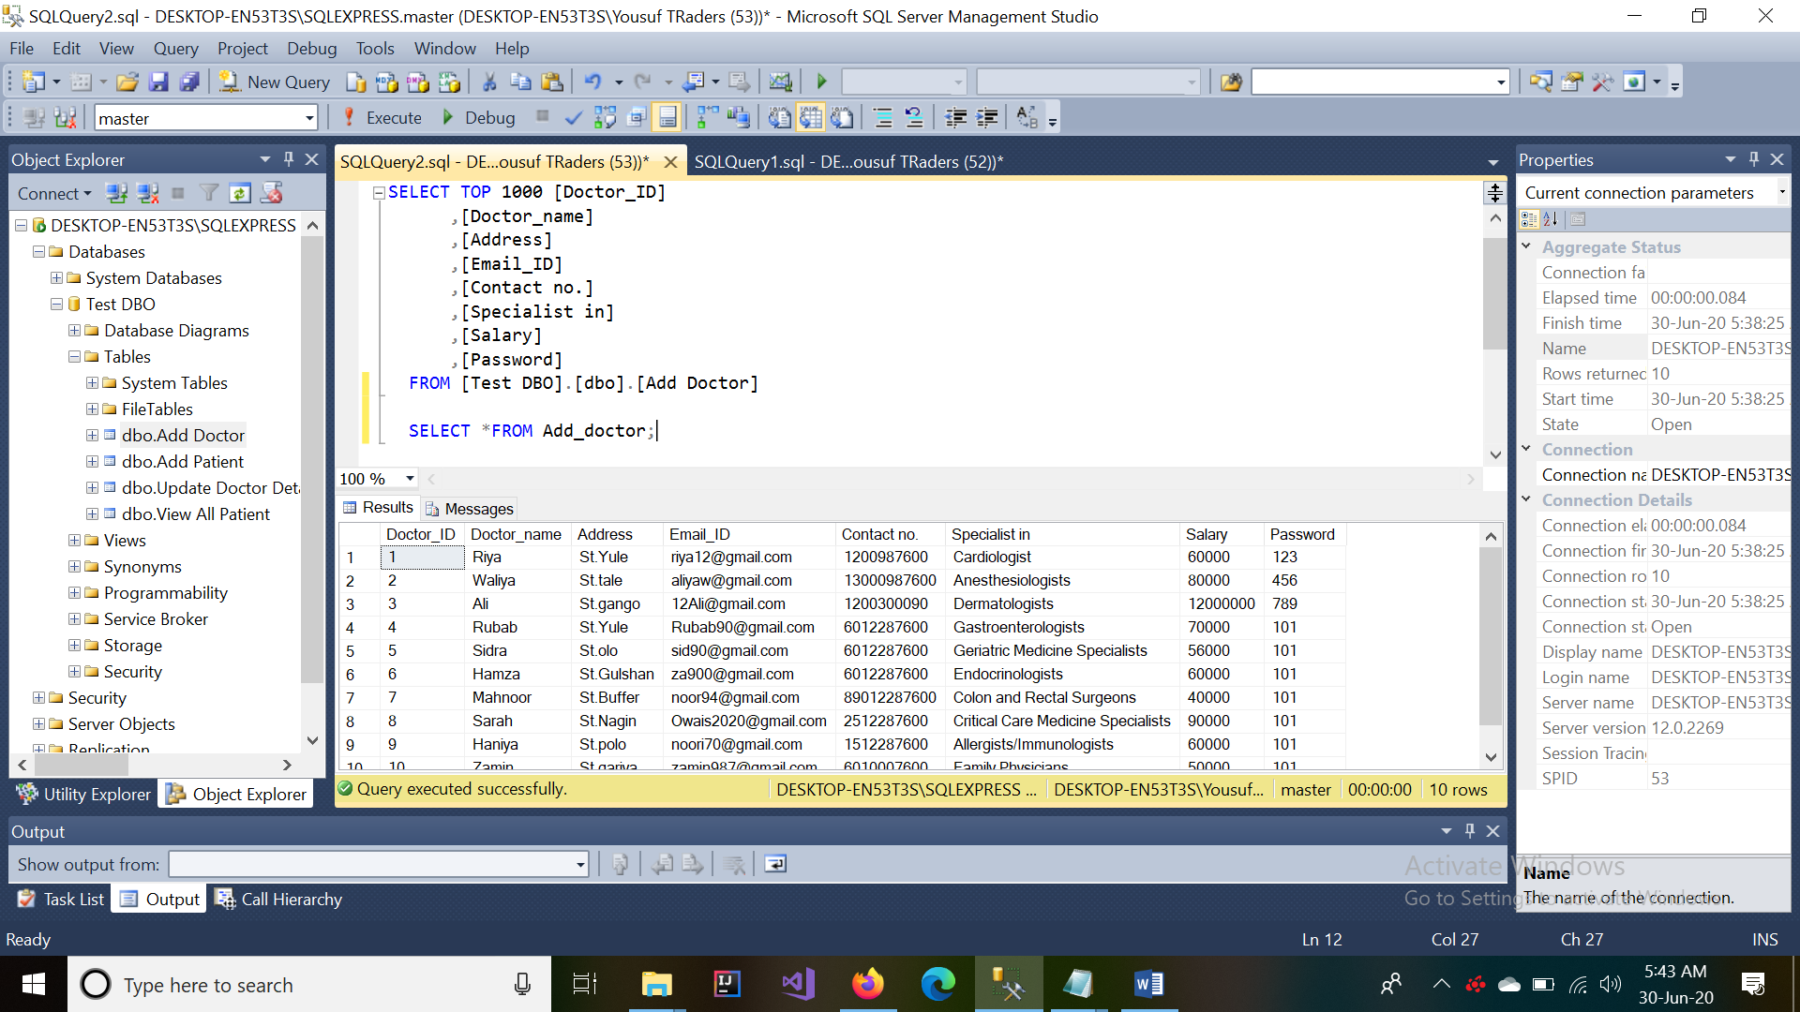**Assignment 05: Add & fetch data**

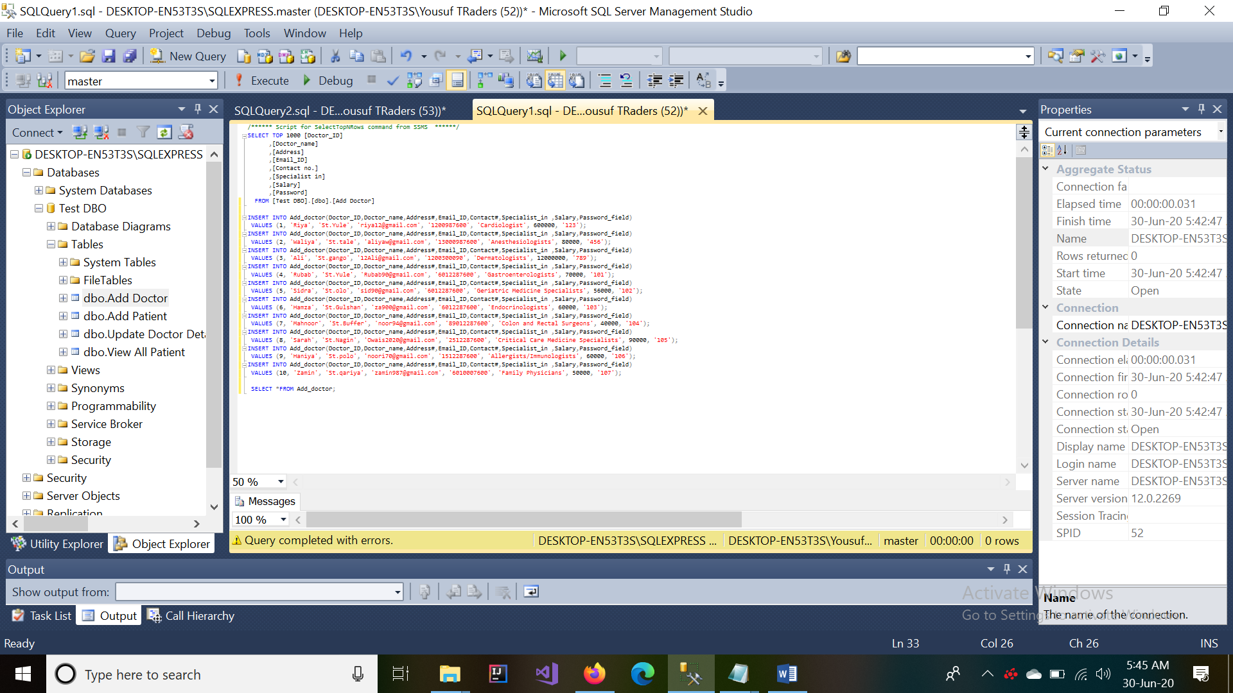NOTE: this is previously made table for practice, I simply choose top 100 rows

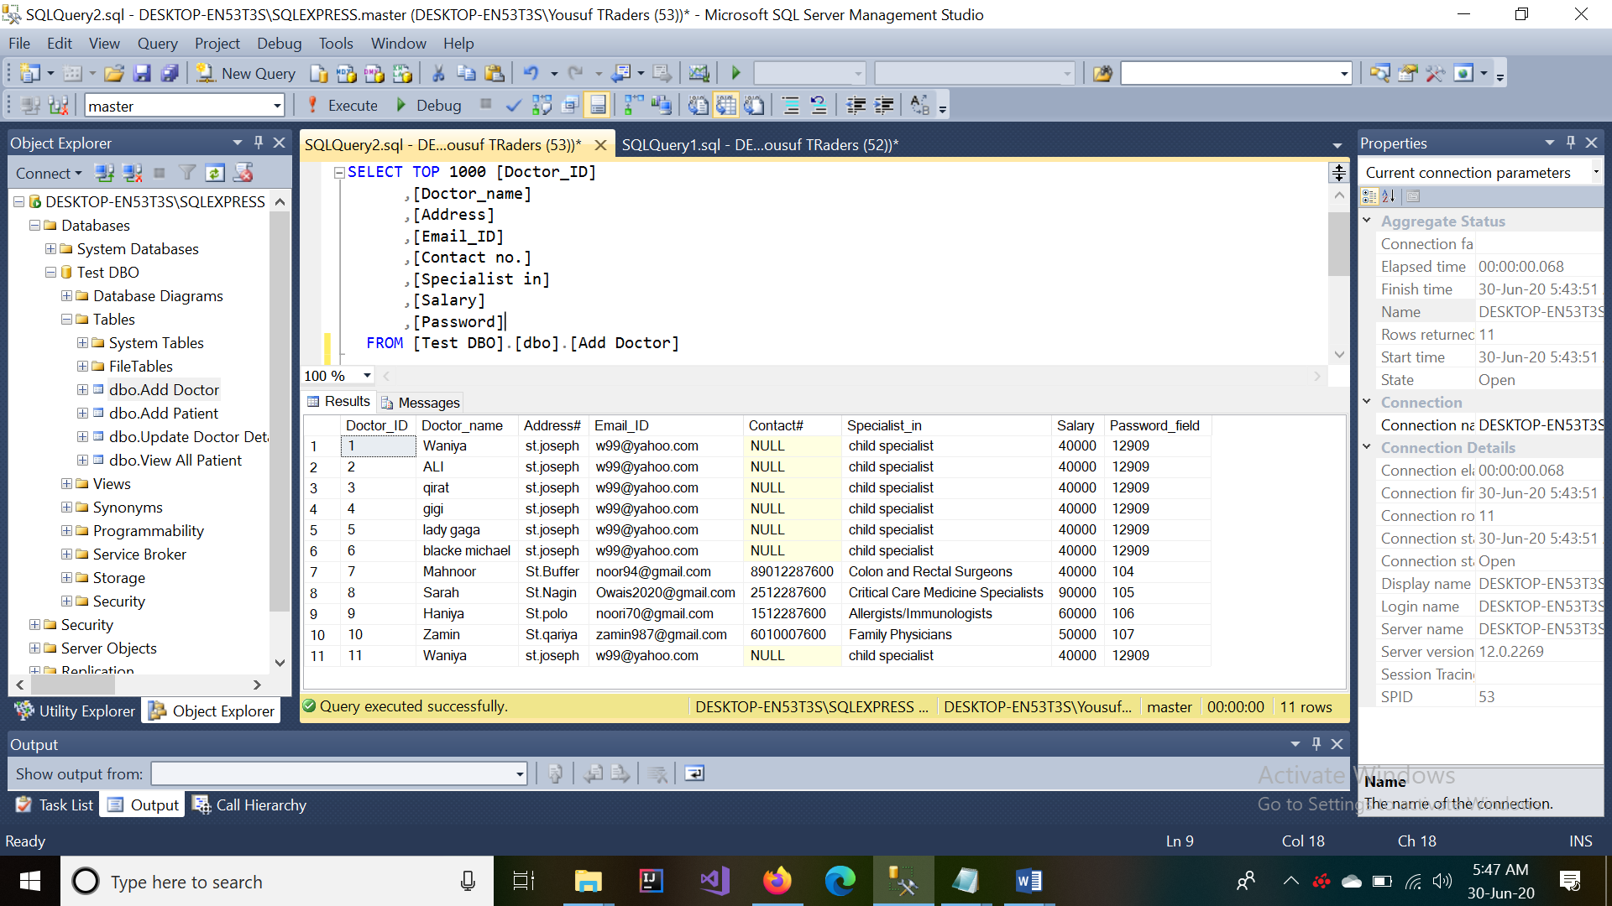

(This above is my further work.)